

**How to Guide: Storefront Promotional Pricing**

**Business Central**

**Dynamics 365**



**Section X: Description**

**TABLE OF CONTENTS**

1 Introduction 3

2 Price Engine 3

3 Sales Price Worksheet 3

4 Import Special Prices 5

5 View/Edit Special Prices 6

6 Basket Offers 7

7 Vouchers 8

8 Discount Offers & Order Amount Gifts 8

9 Update “On Promotion” Filter 9

10 Split Overlapping Prices 9

# Introduction

Pricing, promotions, and vouchers.

# Price Engine

Best price or discount vs the Item Unit Price (List Price) wins.

Sales Order Line Price columns and calculations

* Original Unit Price:
  + Item Unit Price / List Price
* SP Unit Price:
  + Customer’s Storefront Price Group Special Price, incl. promo offer Item & price (gift item at zero and any price)
* Promo SP Unit Price:
  + *SF-PROMO* Price Group Special Price, incl. *Min. Order Amount Excl.* qualifier.
* Basket Offer Unit Price
  + Associated basket offer unit price
* Sales Line Discount %
  + Customer’s Disc. Group Sales Line Discounts
* Promotion Discount %
  + Voucher Code based discount by Item Category, Item, Unit of measure and/or Vendor
* Customer Discount %
  + By Customer, Discount Group and/or all customers
* Item Discount %
  + By by Item Category, Item, Unit of measure and/or Vendor
* Max. Discount % & Discount Exclusion
  + Cap or exclude discounts by Item Category, Item, Unit of measure and/or Vendor
* Payment Discount %:
  + Payment Method associated discount %
* Voucher Amount
  + Voucher creation and issue
  + Total amount discounts, based on voucher redemptions
* Order Gifts:
  + Min. Order Amount based
  + Gift Item added to the order

# Sales Price Worksheet

Create new prices based on the Item’s Unit Price or current/previous Special Price:

* Filter Items or Prices
  + Specify adjustment factor
    - Old Price x adjustment factor = New Price
    - 0.8 adjustment factor = 20% price reduction
    - 1.1 adjustment factor = 10% price increase
  + Select Create New Prices
* Review New Unit Price, edit if required.
* Implement Price Change to create new Special Prices using the New Unit Price from the worksheet

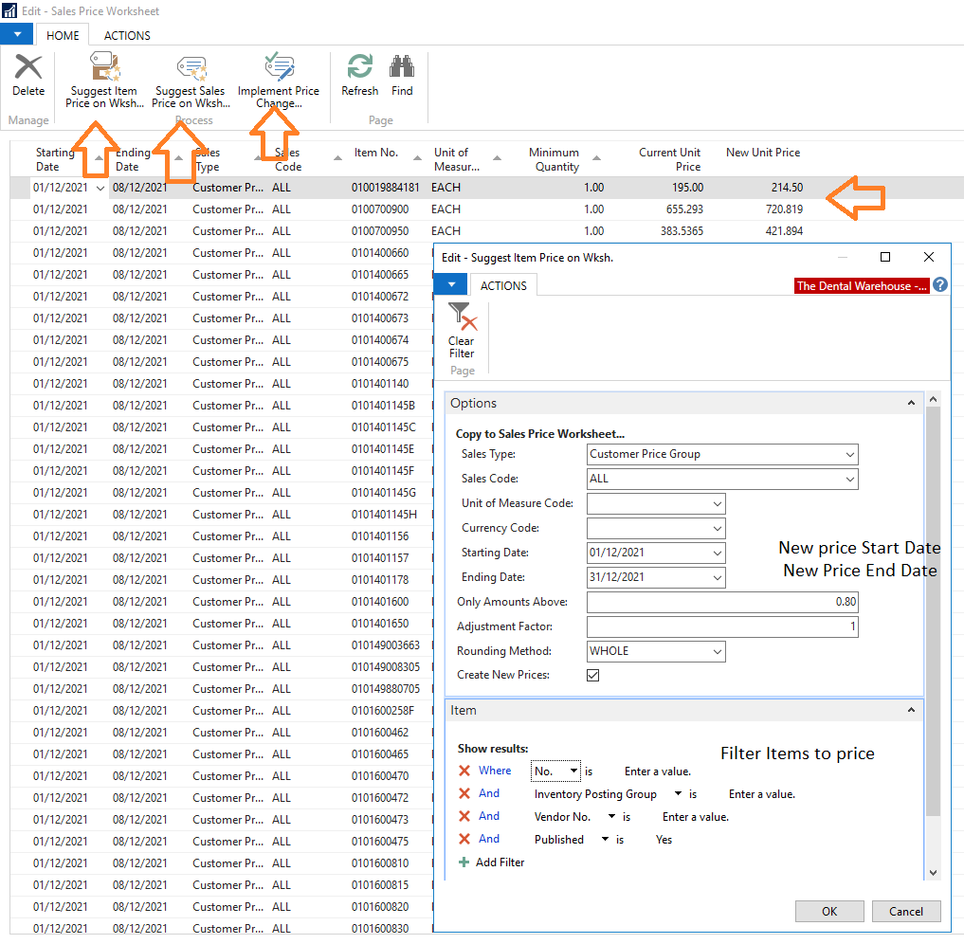

# Import Special Prices

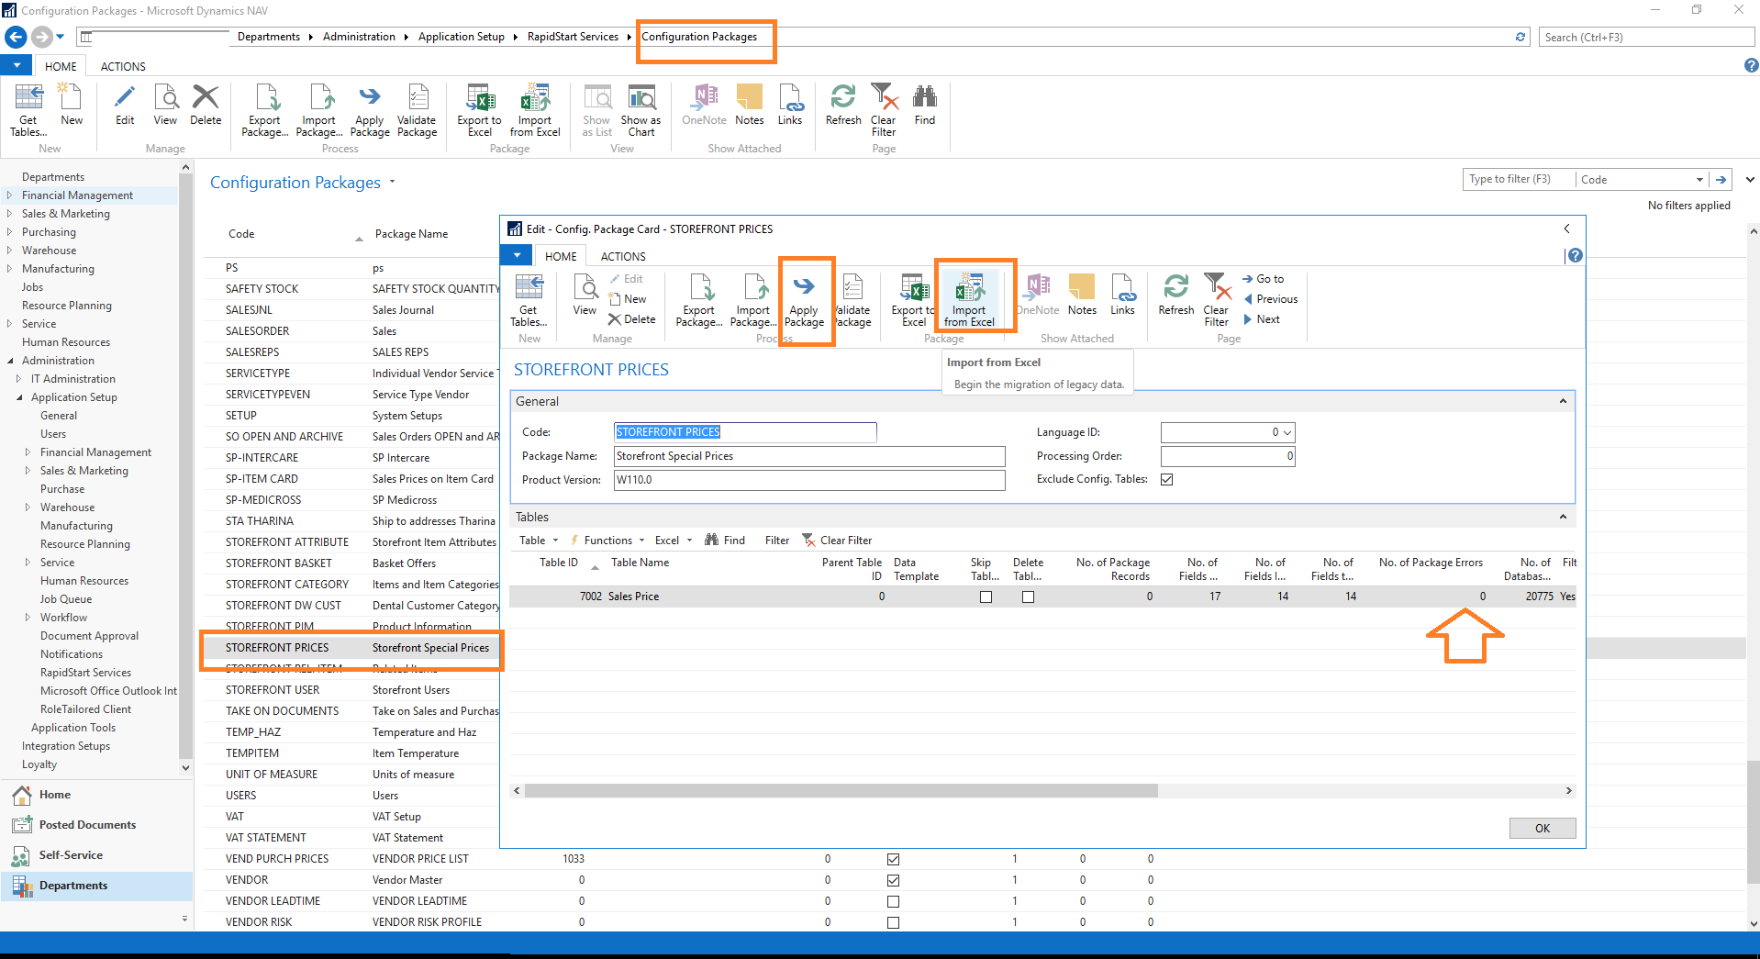

* Search Configuration Packages
* Navigate to and open STOREFRONT PRICES
* Import from Excel
  1. Excel Import Template:

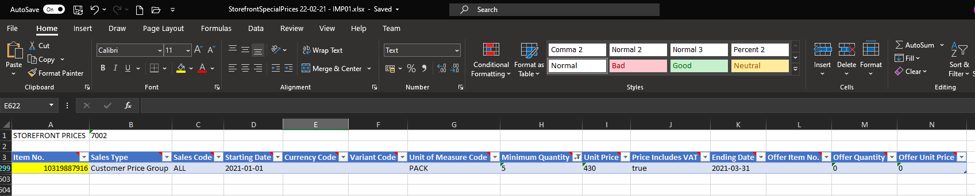



* Apply Package
* Drilldown into *“No. of Package Error”,* if any, to view any import errors.
  1. To fix unit of measure import errors: Set the Sales Price UOM to the Item Card “*Sales Unit of Measure”*:

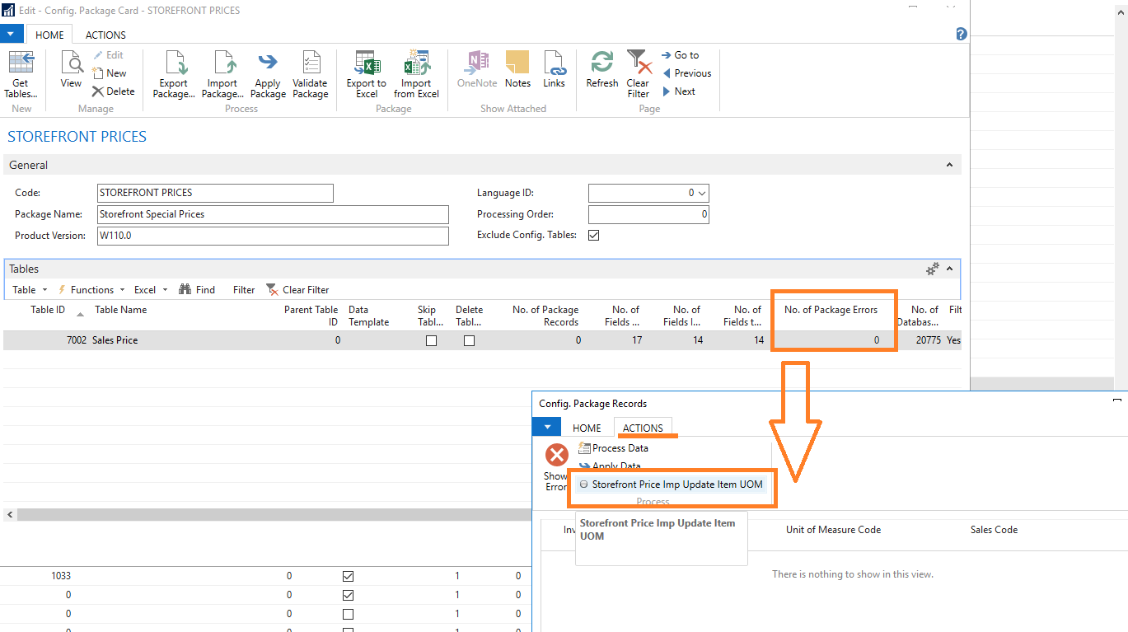

# 

# View/Edit Special Prices

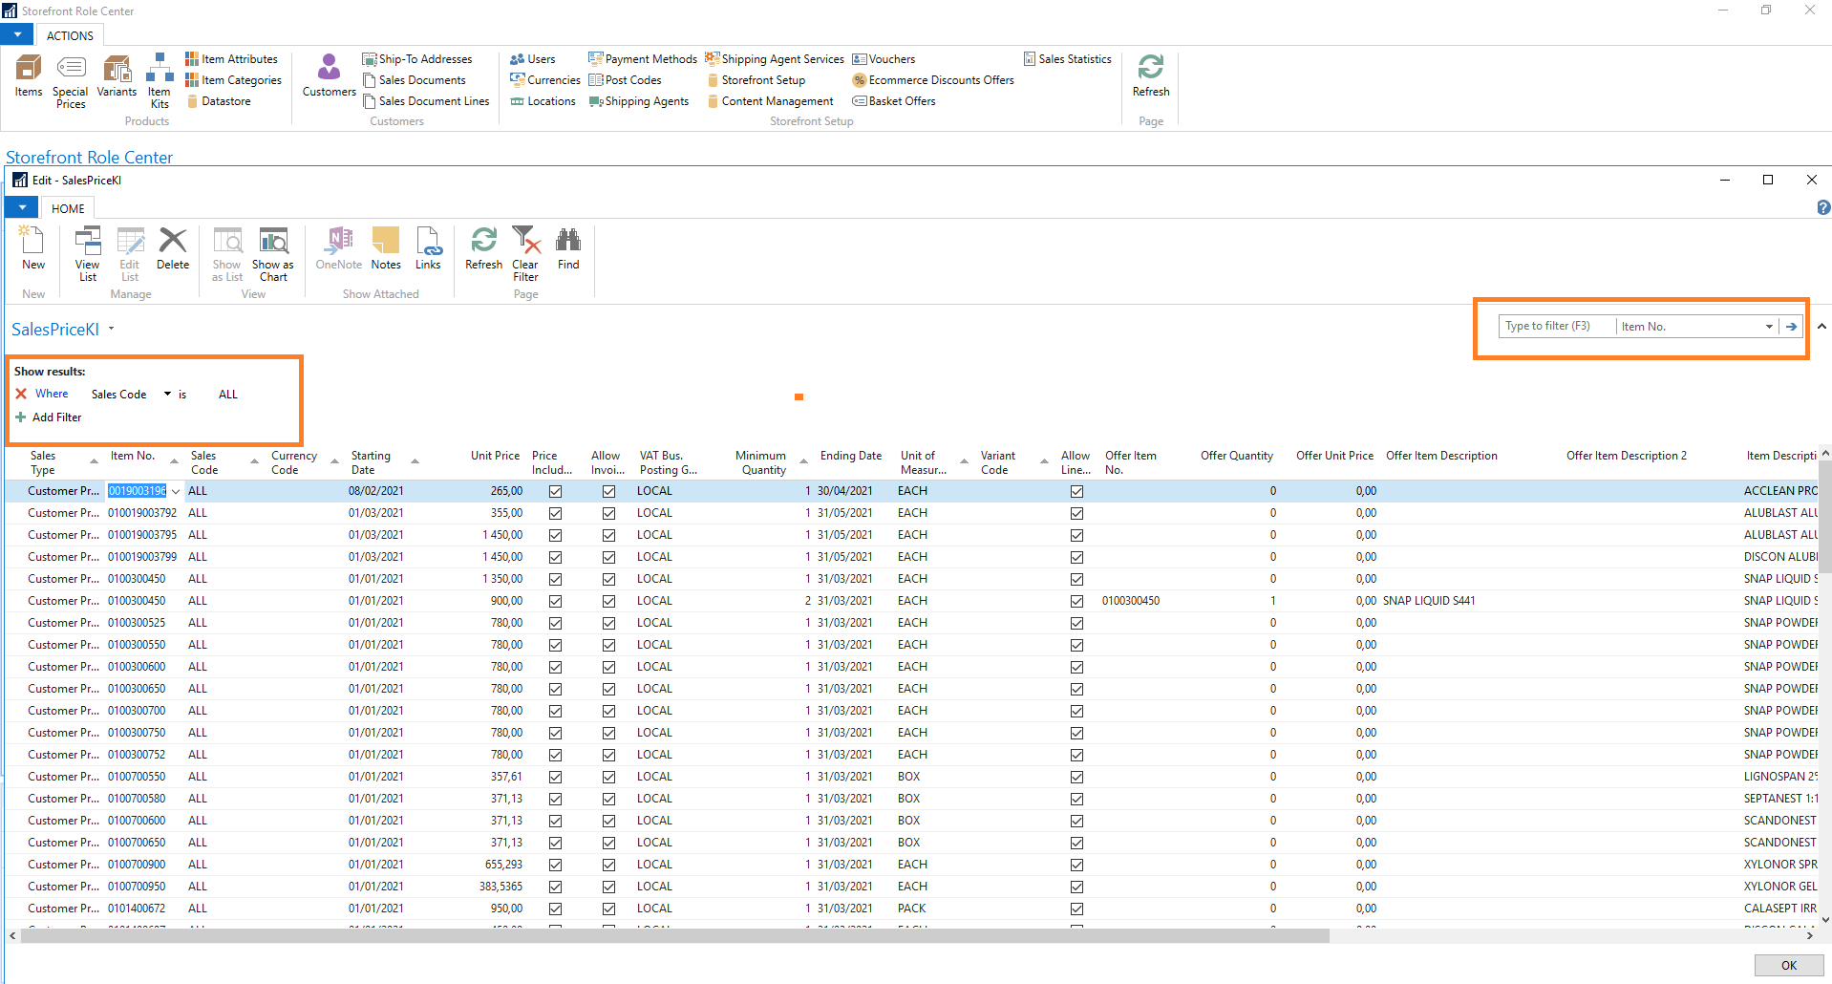

* Special Prices action menu from the Item List/Card or Search Storefront Role Center
* Select Special Prices to view and edit prices
  1. Advanced Page Filter

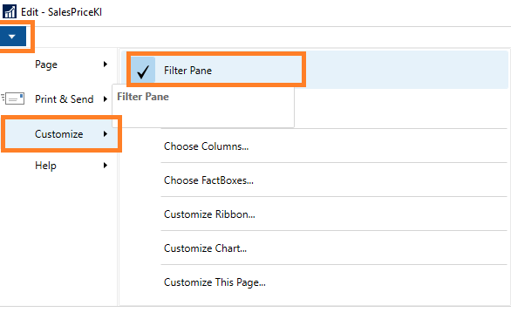

# Basket Offers

* Search Storefront Role Center
* Select Basket Offers to view and edit
* New Offer: Select New:

Basket Offer:

Use case:

* Buy any 2 of X number of products (basket) and get Y at Rx and Z at Rx (offer)
* Buy X, get Y for Free (or at R z)
* Buy any 4 x OR y , get a A or B FREE (multiple options)

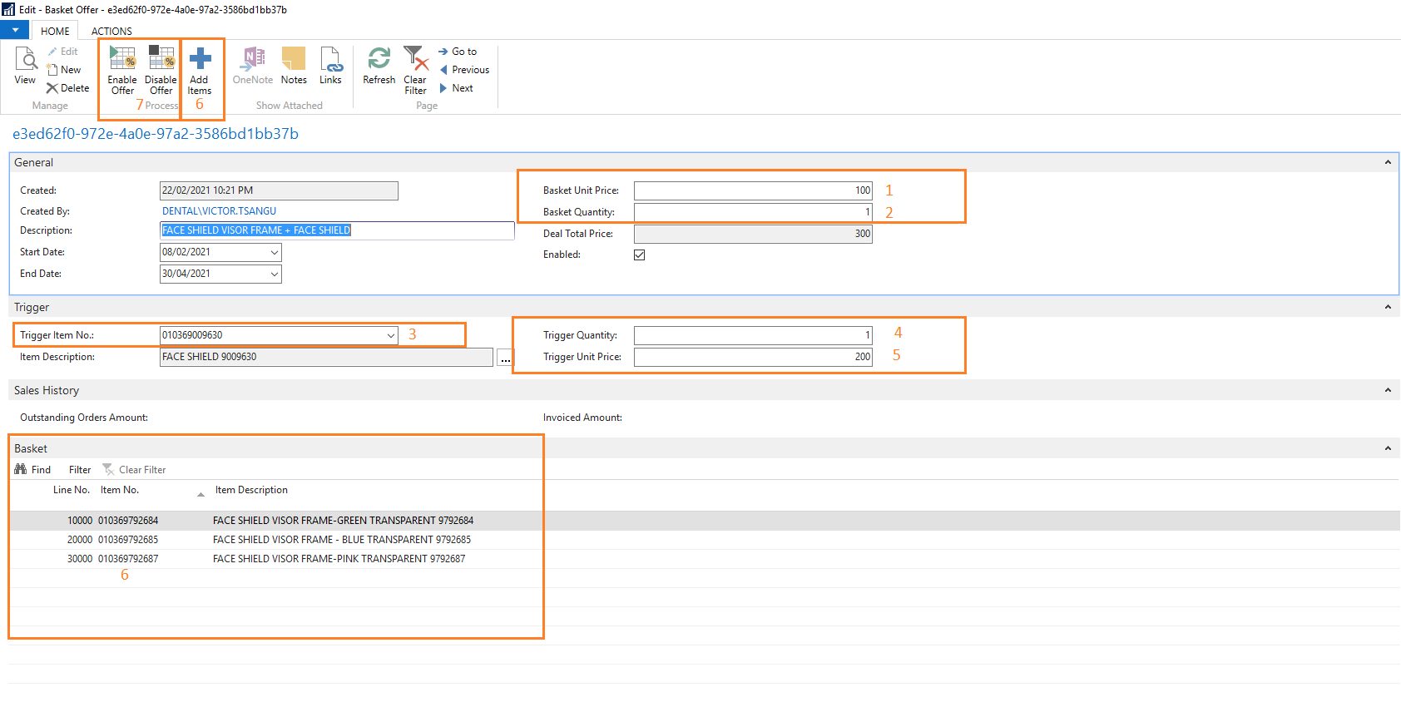

* 1. Basket Item(s) Unit Price (Apply to Basket Lines)
     + Or override the unit price on the basket lines
  2. Basket Quantity
     + Total quantity of the basket items (example: Any 3, Any 5, etc.)
  3. Optional Trigger Item
     + Optional Trigger item (example: Any 5 and this item)
     + Optional Trigger item quantity
     + Optional Trigger Unit Price (Mandatory if Trigger Item is specified)
  4. Basket Items (example: Items which make up the Any 5)
     + Add manually on the lines
     + Select Add Items > filter the Item List > Select all required > select OK.
  5. Offer Items
     + Items offered when the basket triggers the offer.
     + Items defaulted onto the Order
     + Quantity:
       - 0 / Zero: User can select one option, out of offer lines.
       - Or specify the total maximum quantity allowed to select.
  6. Enable or disable the offer
     + Only enabled offers apply to Only enabled offers apply to the shopping cart price calculation.

Total Amount Offer:

* Offer Type: Total Amount
* Total Amount: Total Order Amount trigger to activate the offer

Lowest Price Offer:

Use Case

* Buy any 4, get the cheapest 1 FREE

Setup

* Offer Type: Basket
* Lowest Price Offer Enabled
* Lowest Price Offer Unit Price: Unit Price applied to the lowest priced item.

Offer examples:

Buy X, get Y for Free (or at R z)

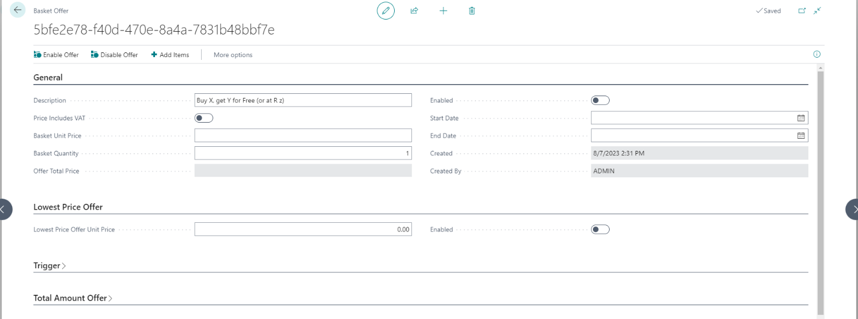

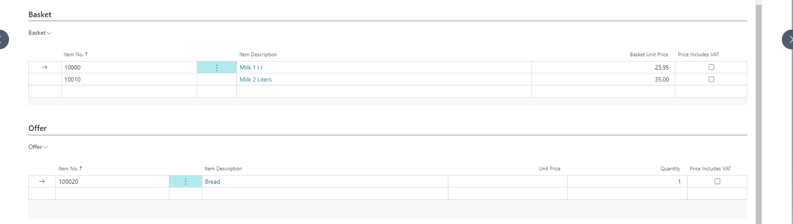

Buy any 4 x OR y , get a A or B FREE (multiple options)

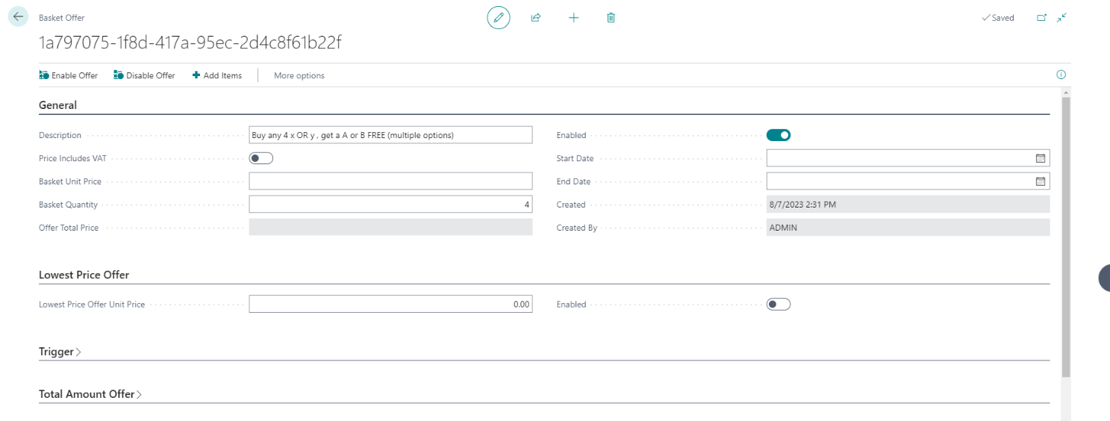

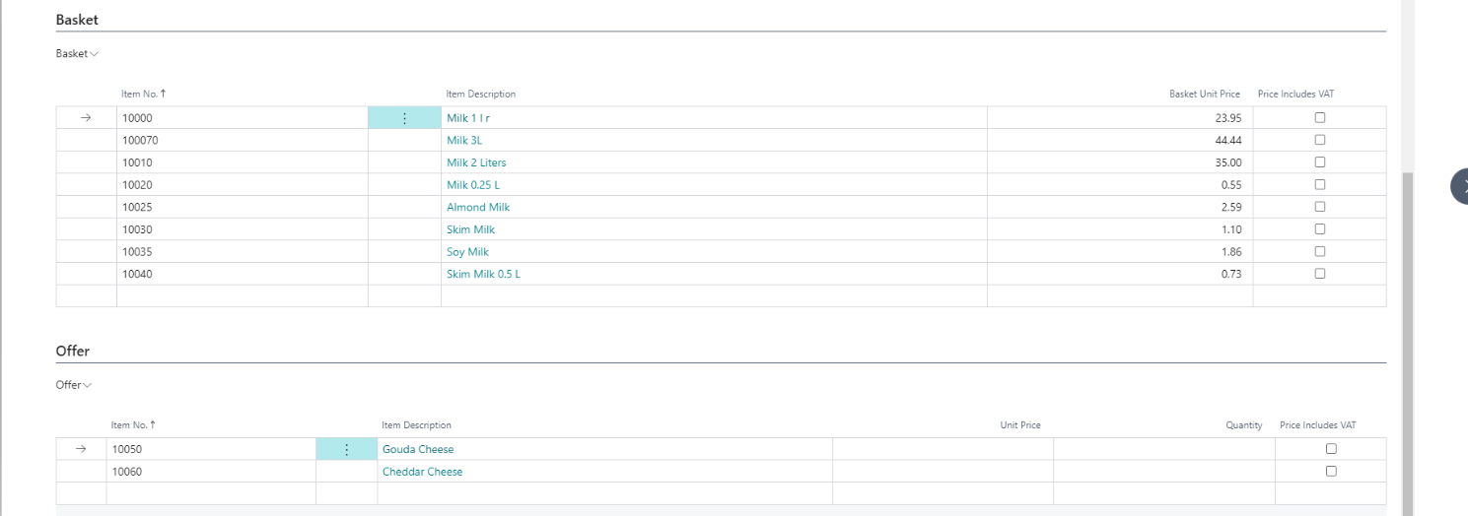

Buy any 4, get the cheapest 1 FREE

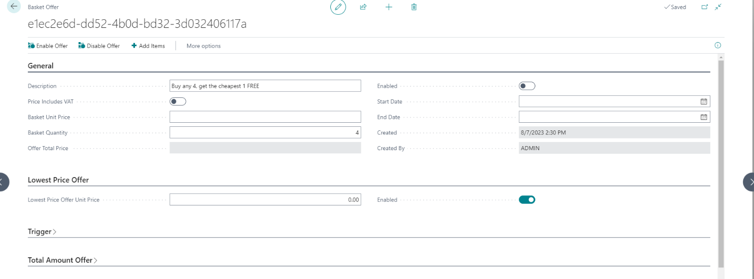

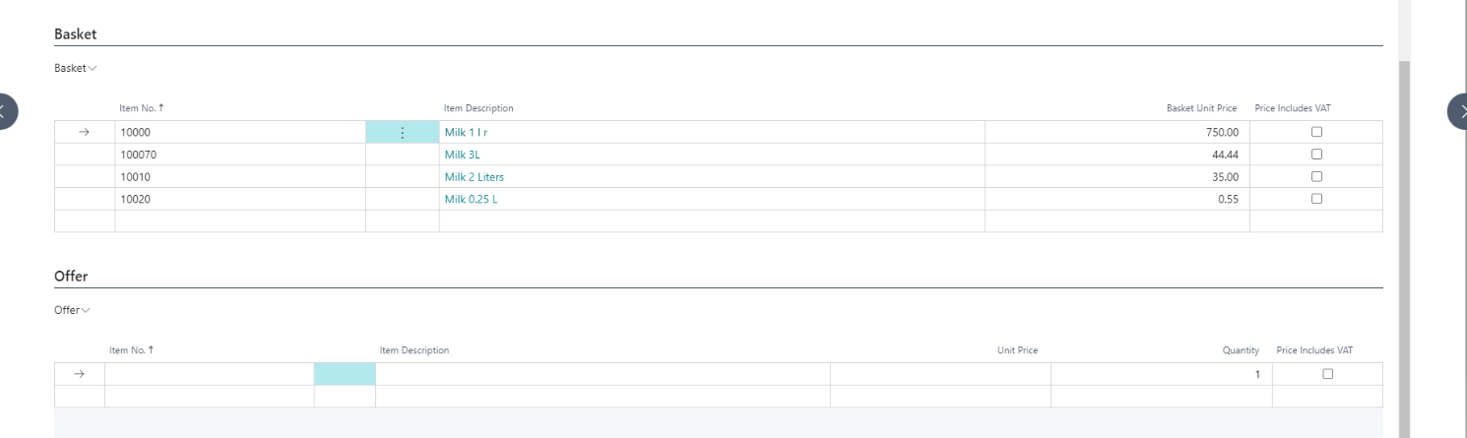

Buy any 2 of X product and get Y at Rx and Z at Rx

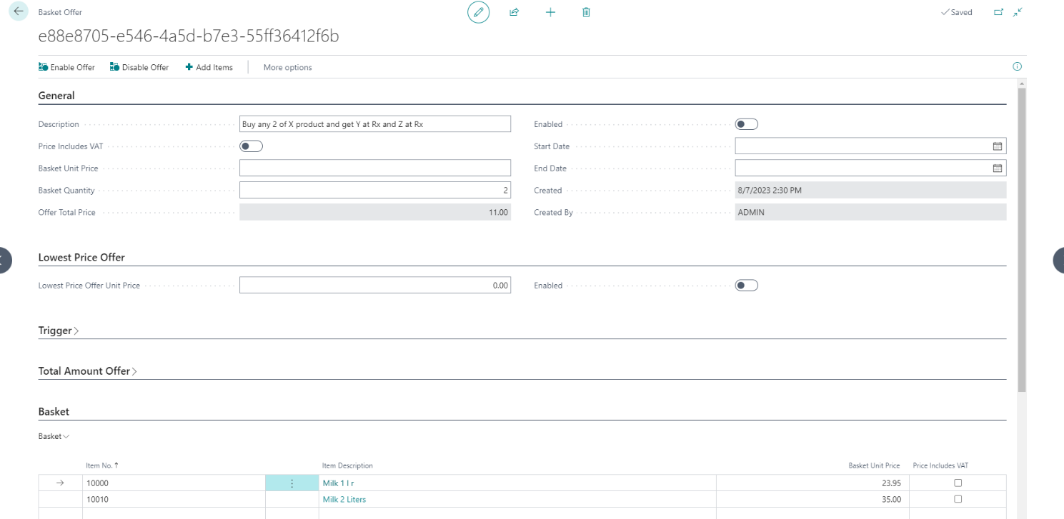

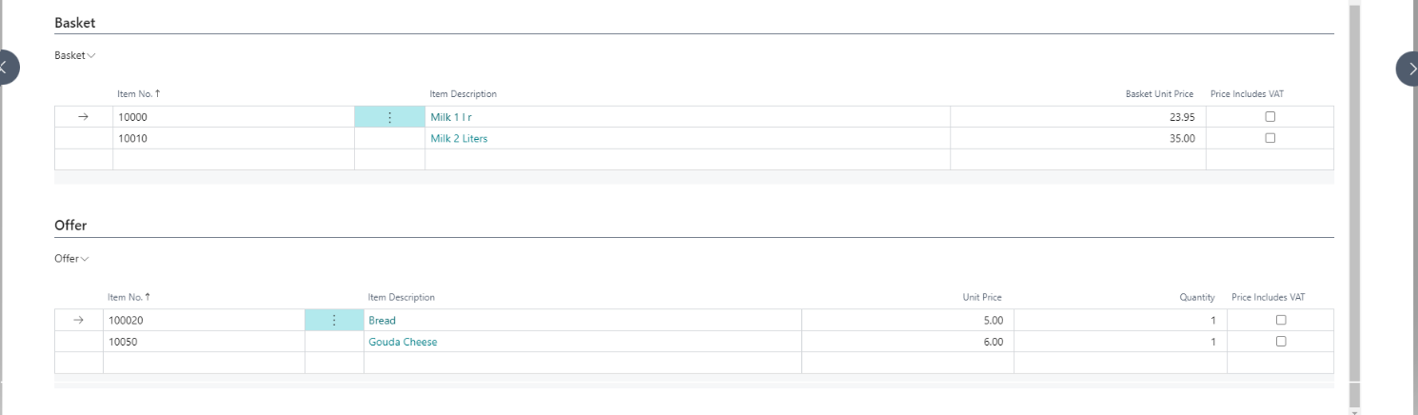

# Vouchers

* Issue new Vouchers, a Voucher Code or No Series, specifying the amount and date.
* Block Vouchers no longer valid
* Voucher redemptions are also tracked here

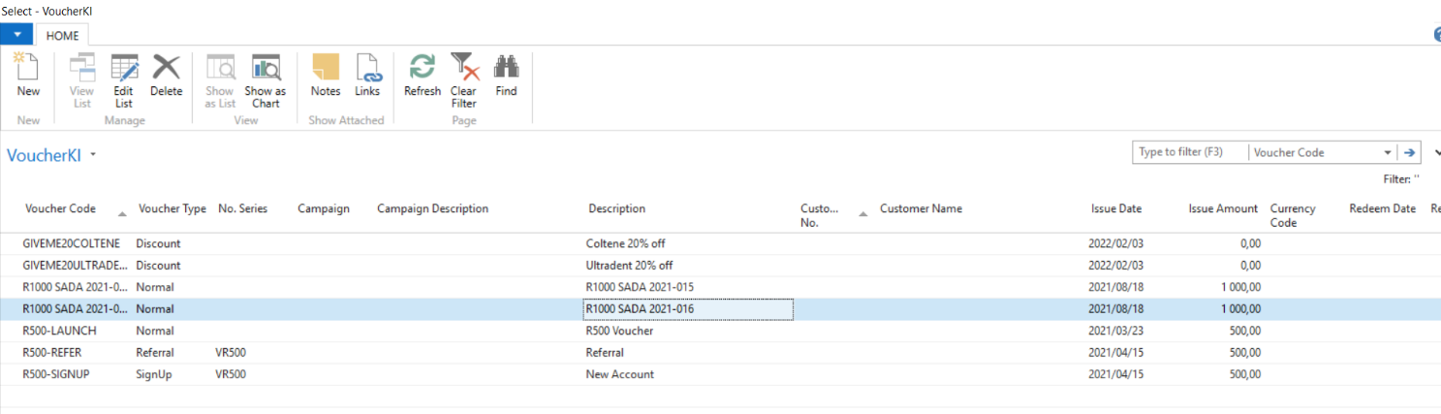

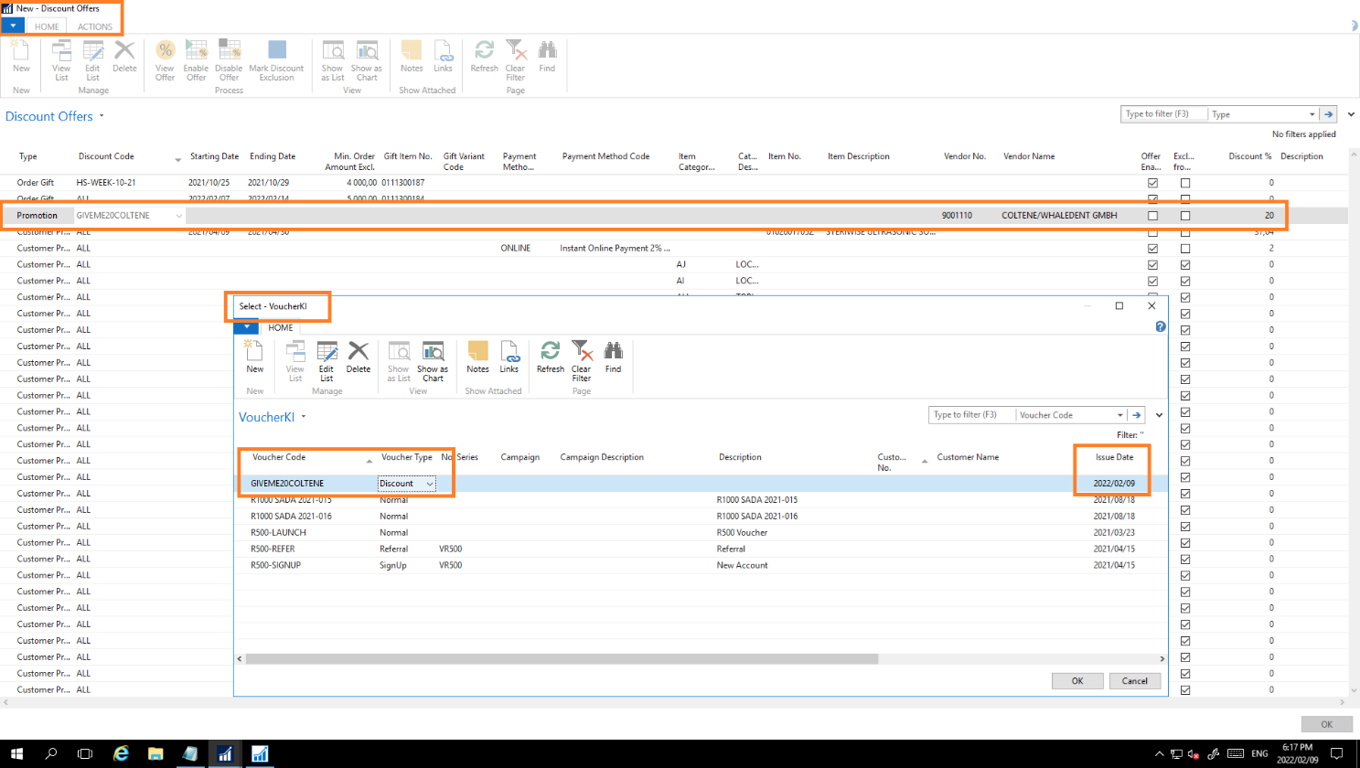

# Discount Offers & Order Amount Gifts

* Discount % by Payment Method, Item (various filters) or promo code.
* Enable the Offer once set up.
* Types:
  1. Order Gift: Min. Order Amount and Gift Item
  2. Promotion Code: Voucher Code, by Item, Discount %
  3. Customer Price Group
  4. Discount Exclusions

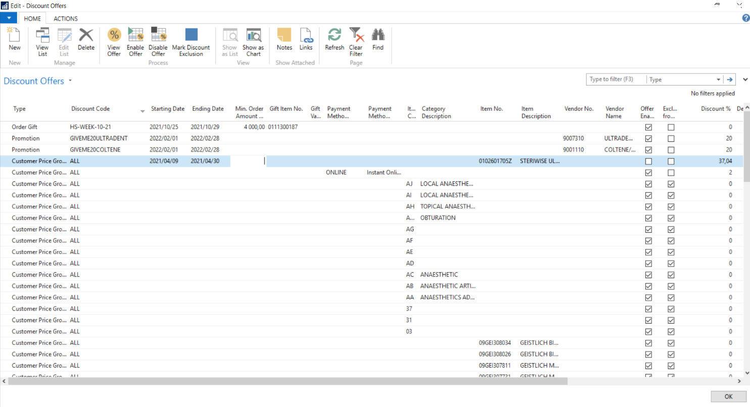

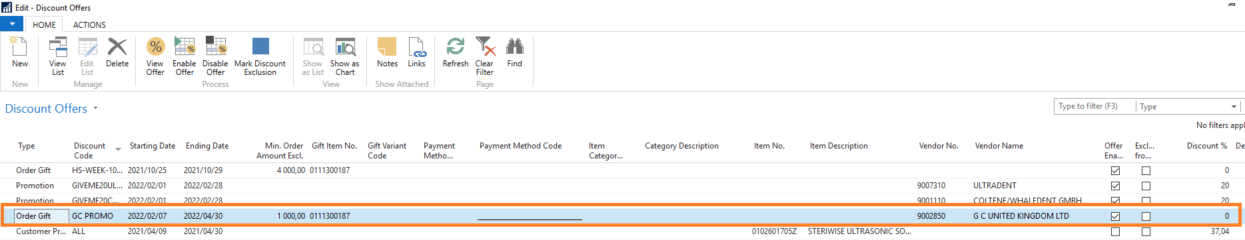

# Update “On Promotion” Filter

* Once all promotion prices and offers have been updated, select the “Create Promo Filter” option.
* Available on Special Prices or Basket Offers pages > ACTIONS > Create Promo Filter

# Split Overlapping Prices

* Available on Special Prices > ACTIONS > Split ALL
* Preview option available to see which prices are affected